# Media Analysis - ChatGPT outperforms copywriters in STEP Conference’s outdoor adverts

## Short Summary

The article details how the STEP Conference leverages ChatGPT to bolster outdoor advertising and in-house content projects, emphasizing AI's role as a supportive tool rather than an overlord replacing human creativity.

## Summary

1. **ChatGPT is being utilized by STEP Conference for creating outdoor advertisements featuring taglines like "Your money needs a side hustle," "Save the planet," and more.  
2. The ad campaign was initially developed using an agency's resources, but ChatGPT proved superior in generating taglines leading to its selection.  
3. STEP Conference plans to continue using ChatGPT for tasks including writing session briefs, creating social posts, and content generation across the team.  
4. The use of AI as an artificial intelligence assistant is making Team STEP faster and more efficient at their jobs.  
5. Dargham explained that while some experts argue AI has created more jobs than it eliminated, concerns arise when AI replaces human copywriters due to its creative limitations compared to humans.  
6. Despite these fears, ChatGPT's potential to augment rather than replace human talent is recognized by Dargham; he believes human creativity will find new roles in an evolving job market.  
7. Dargham acknowledged the existential threat posed by AI tools like Meta's Open Pretrained Transformer, Microsoft's Bing, and Google's Bard, but remains optimistic about their complementary nature to human capabilities rather than direct replacement.

## Question 1:

How do the media in this article frame the public discussion about ChatGPT? Are there certain **metaphors** that keep cropping up?

The media in this article frames the public discussion about ChatGPT using progress and threat metaphors, describing it as an innovative tool for productivity enhancement, a potential existential crisis due to automation concerns, and a hybrid complement or replacement for human talent.

## Question 2:

Which role does or might the Arabic World play in the development of Artificial Intelligence? Answer with 'Not mentioned' if not applicable.

Not mentioned

## Question 3:

Which use cases of Artificial Intelligence are helpful for the Arabic world based on this article?

The article highlights several instances where AI, specifically ChatGPT, is used beneficially in the Arabic world Advertising campaigns, content creation and summarization, and assistance to human talent.

## Question 4:

What is the final message of the article that the author wants to convey? Keep your answer short and precise!

AI tools like ChatGPT can both complement and potentially replace human talent, while emphasizing the value of human creativity in this evolving landscape.

## Sentiment

The sentiment is 4

## Entities

Dargham Clari

## Topic Clusters

### Cluster: AI-driven advancements

ChatGPT performance, AI-generated advertisements

### Cluster: Social media impacts

### Cluster: Ethical considerations

## Word Clouds

### Wordcloud of content

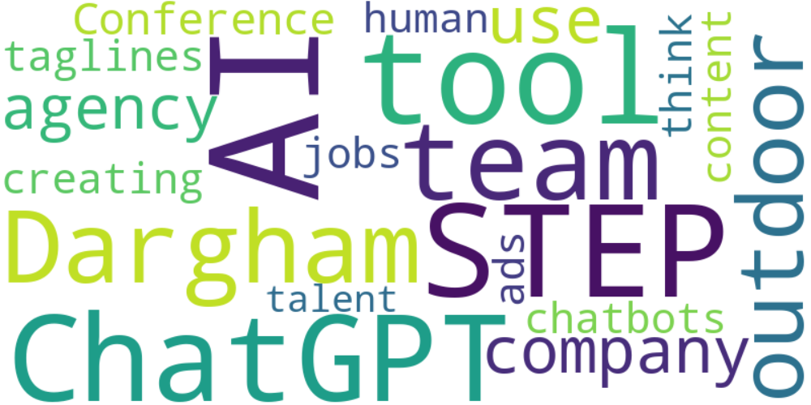

Top 10 words:

- AI: 10

- STEP: 7

- ChatGPT: 6

- like: 6

- team: 5

- Dargham: 5

- outdoor: 4

- company: 4

- use: 4

- agency: 4

### Wordcloud of summary



Top 10 words:

- ChatGPT: 4

- AI: 4

- human: 4

- STEP: 3

- Dargham: 3